TRI and Succeed Sports Staff Assignment.

The snippet below shows landing page for the sports staff.

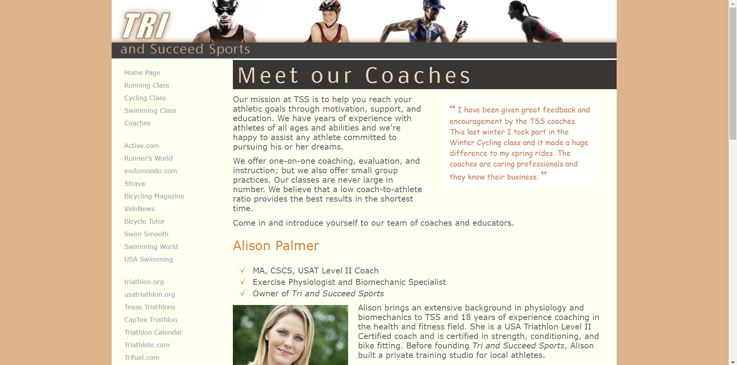

The following snippets show some of the CSS code that went into creating the layout and style elements of the webpage.

